**VELAMMAL BODHI CAMPUS**

**GRADE: X GRAND TEST IV DATE: 22.01.2024**

**MATHS**

**Duration: 3Hrs.                                                                           MARKS: 80**

**GENERAL INSTRUCTIONS:**

1. This Question Paper has 5 Sections A, B, C, D and E.
2. Section A has 20 MCQs carrying 1 mark each
3. Section B has 5 questions carrying 02 marks each.
4. Section C has 6 questions carrying 03 marks each.
5. Section D has 4 questions carrying 05 marks each.
6. Section E has 3 case based integrated units of assessment (04 marks each) with sub- Parts of the values of 1, 1 and 2 marks each respectively.
7. All Questions are compulsory. However, an internal choice in 2 Questions of 5 marks, 2 Questions of 3marks and 2 Questions of 2 marks has been provided. An internal choice has been provided in the 2marks questions of Section E
8. Draw neat figures wherever required. Take π =22/7 wherever required if not

stated.

**Section A**

**I Section A has 20 MCQs carrying 1 mark each.**

1. The HCF and LCM of two numbers are 33 and 264 respectively. When the first number is completely divided by 2 the quotient is 33. The other number is:

           (a)   66         (b)   130             (c)   132              (d)   196

1. If one zero of the quadratic polynomial x² + 3x + k is 2, then the value of k is

            (a) 10            (b) -10                 (c) 5                      (d) -5

1. For which value (s) of p, will the lines have represented by the following pair of linear equations be parallel 3x -  y - 5 = 0 ,     6x - 2y -  p = 0

      (a) all real values except 10          (b) 10         (c) 5/2            (d) 1/2

1. Half the perimeter of a rectangular garden, whose length is 4 m more than its width, is 36 m. The dimensions of    garden will be

          (a) 20 m by 16 m             (b) 36 m by 10 m

(c) 16 m by 30 m         (d) 30 m by 15m

1. If the 17th term of an A.P. exceeds its 10th term by 7. The common difference is:

           (a) 1                             (b) 2                               (c) 3                              (d) 4

1. Two APs have the same common difference. The first term of one of these is –1 and that of the other is – 8. The difference between their 4th terms is

        (a)1                             (b)-8                             (c)7                                       (d) -9

1. In 𝛥 ABC, DE || AB. If AB = a, DE = x, BE = b and EC = c. Then express x in terms of a, b and c.

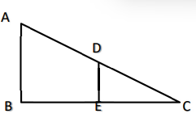

       (a) $\frac{ac}{b}$                    (b) $\frac{ac}{b+c}$                           (c) $\frac{ab}{c}$ (d) $\frac{ab}{b+c}$

1. If the distance between the points A (p , 4 ) and B(1, 0) is 5 units then the value(s) of p is

        (a) 4 only           (b) -4 only                       (c)±4                                (d) 0

1. $\frac{1}{1+sinθ}$ + $\frac{1}{1-sinθ}$ = ?

(a) 1 (b) 2sec2 θ (c) 2sin2 θ (d) 2cos2 θ

1. If sin θ + sin²θ = 1, then cos² θ + cos 4 θ = ---

         (a) -1                    (b) 0                             (c) 1                                (d) 2

1. The angle of elevation of the top of a building 30 m high from the foot of another building in the same plane is 60°, and also the angle of elevation of the top of the second tower from the foot of the first tower is 30°, then the distance between the two    buildings is:

           (a) 10√3 m                (b) 15√3 m            (c) 12√3 m                      (d) 36 m

1. In figure, AP, AQ and BC are tangents of the circle with centre O. If AB = 5 cm, AC = 6 cm and BC = 4 cm, then the length of AP (in cm) is

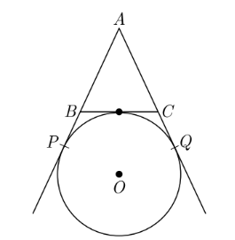

          (a)15cm                    (b)10cm              c) 9 cm                              (d) 7.5cm

1. If the area of a circle is numerically equal to twice its circumference, then the diameter of the circle is

       (a) 4 units                    (b) n units            (c) 8 units                    (d) 2 units

1. If two solid hemispheres of same base radii r, are joined together along their bases, then curved surface area of this new solid is

        (a) 4πr2                     (b) 6πr2                              (c) 3πr2             (d) 8πr2

1. A tank is made of the shape of a cylinder with a hemispherical depression at one end. The height of the cylinder is 1.45 m and radius is 30 cm. The total surface area of the tank is:

       (a) 30 m2                    (b) 3.3 m2                          (c) 30.3 m2        (d)3300 m2

1. The mode and mean are given by 7 and 8, respectively. Then the median is:

       (a) 1/13                      (b) 13/3                             (c) 23/3               (d) 33

1. If the mean of first n natural numbers is $\frac{3n}{5}$, then the value of n is:

       (a) 3                           (b) 4                                    (c) 5                   (d) 6

1. A letter of the English alphabet is chosen at random, what is the probability

that the letter chosen   is a consonant?

(a) $\frac{5}{26}$                  (b) $\frac{21}{26}$                            c) $\frac{2}{13}$                      (d) $\frac{7}{13}$

**Question no. 19 and 20 Assertion and Reason type questions:**

(a) Both assertion(A)and reason (R)are true and reason (R)is the correct explanation of assertion (A)

(b) Both assertion (A) and reason (R) are true and reason (R) is not the correct explanation of assertion (A)

(c) Assertion (A) is true but reason (R) is false.

(d) Assertion (A) is false but reason (R) is true.

1. Assertion: The H.C.F. of two numbers is 16 and their product is 3072. Then their L.C.M. = 162.

Reason: If a and b are two positive integers, then H.C.F. × L.C.M. = a × b.

1. Assertion: Ratio in which the line 3x + 4y = 7 divides the line segment joining the points (1, 2) and (- 2, 1) is 3 : 5

Reason: The coordinates of the point P (x, y) which divides the line segment joining the points A (x1, y1) and B (x2, y2) in the ratio m1: m2 is

**Section-B**

**II.  Section B has 5 questions carrying 02 marks each.**

1. A fraction becomes $\frac{1}{3}$  when 1 is subtracted from the numerator and it becomes $\frac{1}{4}$     when 8 is added to its denominator. Find the fraction.
2. In ∆ABC, DE || BC, find the value of x.

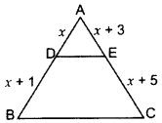

1. If sec2 θ (1 + sin θ) (1 – sin θ) = k, then find the value of k.
2. If PA and PB are tangents drawn from external point P such that PA = 10cm and , = 600 , find the length of chord AB.

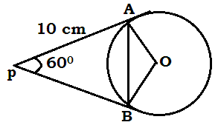

**(OR)**

Two concentric circles are of radii 5 cm and 3 cm. Find the length of the chord of the larger circle which touches the smaller circle.

1. Area of a sector of a circle of radius 14 cm is 154 cm2. Find the length of the

corresponding arc of the sector. [Use π = 22/7].

**(OR)**

Find the area of the sector of a circle with radius 4 cm and of angle 30°. Also, find the area of the corresponding major sector. (Use π = 3.14)

**Section-C**

1. **Section C has 6 questions carrying 03 marks each.**
2. Prove that √3 is irrational.
3. If α and β are the zeroes of a quadratic polynomial x2 + x – 2 then find the value of ($\frac{1}{α}-\frac{1}{β}$).
4. If 51x + 23y = 116 and 23x + 51y = 106, then find the value of (x – y).
5. Prove that $\sqrt{\sec^{2}θ+ {cosec}^{2}θ}$ = tan $θ$ + cot $θ$

**(OR)**

If (1 + m2) x2 + 2mcx + c2 – a2 = 0 has equal roots, then show that c2 = a2(1 + m2)

1. Two tangents PQ are PR are drawn to a circle with centre O from an external point P. Prove that ∠QPR = 2 ∠OQR.

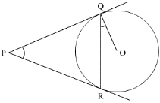

**(OR)**

A circle is inscribed in a $Δ$ ABC, with sides AC, AB and BC as 8 cm, 10 cm and 12 cm respectively. Find the length of AD, BE and CF.

1. All the black face cards are removed from a pack of 52 playing cards. The reaming cards are well shuffled and then a card is drawn at random. Find the probability of getting

(i) face card (ii) red card (iii) black card.

**Section-D**

**Section D has 4 questions carrying 05 marks each.**

1. A train travels at a certain average speed for a distance of 54 km and then travels a distance of 63 km at an average speed of 6 km/hr more than the first speed. If it takes 3 hours to complete the total journey, what is its first speed?

**(OR)**

Find the value of p for which the quadratic equation

(p + l)x2 – 6(p + 1)x + 3(p + 9) = 0, p ≠ 1 has equal roots. Hence, find the roots of the equation.

1. a) If the coordinates of points A and B are (-2, -2) and (2, – 4) respectively, find the coordinates of P such that AP = $\frac{3}{7}$ AB, where P lies on the line segment AB.

b) Points A (-l, y) and B(5,7) lie on a circle with centre O (2, -3y). Find the values of y. Hence, find the radius of the circle.

1. A solid right-circular cone of height 60 cm and radius 30 cm is dropped in a right- circular cylinder full of water of height 180 cm and radius 60 cm. Find the volume of water left in the cylinder, in cubic metre.
2. Find the mean, median and mode of the following data:

Statistics Class 10 Maths CBSE Important Questions With Solutions 75

**(OR)**

Weekly income of 600 families is given below

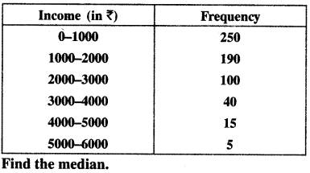

**Section-E**

1. **CASE BASED QUESTION.**
2. Bequests to Charity: At the time our mother left this Earth, she gave Rs 90000 to her children of birth. This we kept and each year added Rs 30000 more, as a lasting memorial from the children she bore. When Rs 4,20,000 is thusly attained, all goes to charity that her memory be maintained.

(i) What was the balance in the sixth year?

(ii) In what year was the goal of Rs 420,000 met?

1. In a GPS, The lines that run east-west are known as lines of latitude, and the lines running north-south are known as lines of longitude. The latitude and the longitude of a place are its coordinates and the distance formula is used to find the distance between two places. The distance between two parallel lines is approximately 150 km. A family from Uttar Pradesh planned a round trip from Lucknow (L) to Puri (P) via Bhuj (B) and Nashik (N) as shown in the given figure below.

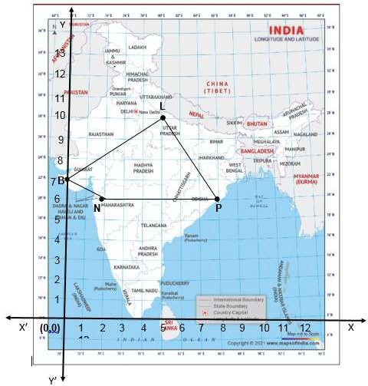

Based on the above information answer the following questions using the coordinate geometry.

* 1. Find the distance between Lucknow (L) to Bhuj(B).
  2. If Kota (K), internally divide the line segment joining Lucknow (L) to Bhuj (B) into 3 : 2 then find the coordinate of Kota (K).
  3. Name the type of triangle formed by the places Lucknow (L), Nashik (N) and Puri (P)

##### (OR)

Find a place (point) on the longitude (y-axis) which is equidistant from the points Lucknow (L) and Puri (P).

1. 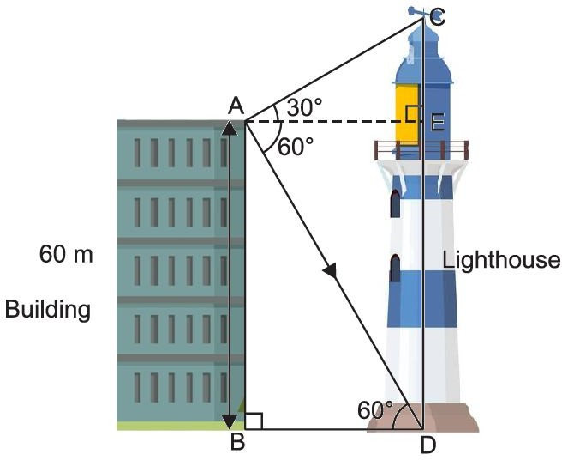Ram is watching the top and bottom of a lighthouse from the top of the building. The angles of elevation and depression of the top and bottom of a lighthouse from the top of a 60 m high building are 30° and 60° respectively.

Find

(i) the difference between the heights of the lighthouse and the building.

(ii) the distance between the lighthouse and the building.

(iii)The ratio of the height of a light house and the length of its shadow on the ground is $\sqrt{3}$: 1 What is the angle of elevation?

**\*\*\*\*\* ALL THE BEST \*\*\*\*\***